SIMATS ENGINEERING (SAVEETHA SCHOOL OF ENGINEERING)
Department of Artificial Intelligence and Data Science

ASSESSMENT TOOL 3 – CODING CHALLENGE

Course Code: | DSA03 | Course Title: | Natural Language Processing
CO Assessed: | CO1 – Imitation (L1) | Assessment: | Assessment Tool 3 – Coding Challenge
Weightage: | 30% of CIA
CO5 Statement: | Analyse NLP models, regular expression patterns, finite state automata, morphological processing techniques and to interpret language processing. (BL-3)
Student Name: | K. V. Sai. Shanmukh | Reg. No.: | 192424306
Section / Batch: | B-TECH AI&DS | Date: | 16-07-2026
Code of Conduct
I K. V. Sai. Shanmukh(192424306) (Name / Reg No) certify that this submission is my original work and that I have adhered to the guidelines specified for this assessment. I understand that any violation of academic integrity rules will result in disciplinary action.
Signature of the Student: K. V. Sai. Shanmukh
Instructions
- Develop a complete and modular Python program that meets all the functional requirements specified in the coding challenge using appropriate algorithms, data structures, and programming practices.
- Test the program using multiple valid and invalid test cases, and clearly display the input, processing, and output to verify the correctness of the implementation.
- Follow standard coding practices by using meaningful variable names, proper indentation, comments, exception handling (where applicable), and upload the source code, sample outputs, and README file to the designated GitHub repository.
- Duration: 40 minutes.

Section / Topic | Focus | Q Nos
Regular Expression Pattern Matching | Regular Expressions, Basic Regular Expression Patterns | 1
Finite State Automata Implementation | Finite State Automata, Models and Algorithms | 2
Advanced Regular Expression Search | Regular Expressions, Basic Regular Expression Patterns | 3

Section 1: Intelligent Email and Password Validator using Regular Expressions.
Problem Understanding:
The objective is to validate user registration details using Regular Expressions (Regex).
The program validates:
- Email Address
- Password
- Mobile Number
according to the given security rules.
Algorithm:
1.Import the re module.
2.Read Email, Password and Mobile Number.
3.Match Email with Regex pattern.
4.Match Password with Regex pattern.
5.Match Mobile Number with Regex pattern.
6.Display Valid or Invalid.
Code:
import re
email = input("Enter Email: ")
password = input("Enter Password: ")
mobile = input("Enter Mobile Number: ")
email_pattern = r'^[A-Za-z][A-Za-z0-9._]*@[A-Za-z]+\.(com|org|edu|net|in)$'
password_pattern = r'^(?=.*[A-Z])(?=.*[a-z])(?=.*\d)(?=.*[@#$%&!])[A-Za-z\d@#$%&!]{8,}$'
mobile_pattern = r'^[6-9]\d{9}$'
if re.fullmatch(email_pattern, email):
print("Valid Email")
else:
print("Invalid Email")
if re.fullmatch(password_pattern, password):
print("Strong Password")
else:
print("Weak Password")
if re.fullmatch(mobile_pattern, mobile):
print("Valid Mobile Number")
else:
print("Invalid Mobile Number")
Output:
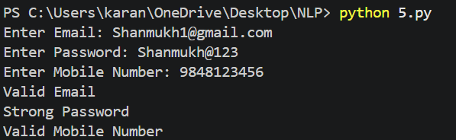

Section 2: Design a Finite State Automata (FSA) Simulator.

Problem Understanding:
The objective is to simulate a Deterministic Finite Automata (DFA).
The DFA accepts strings ending with "ab".
The program should
- Accept multiple strings
- Show transition path
- Display Accepted or Rejected
Algorithm:
- Define DFA transitions.
- Read number of input strings.
- For each string:
  - Start from initial state.
  - Process each character.
  - Update state.
  - Record transition path.
- If final state is reached after processing all characters, accept the string.
- Otherwise reject it.
Code:
dfa = {
'q0': {'a': 'q1', 'b': 'q0'},
'q1': {'a': 'q1', 'b': 'q2'},
'q2': {'a': 'q1', 'b': 'q0'}
}
final_state = "q2"
user_input = input("Enter a string to test: ")
strings = [user_input]
try:
count = int(user_input)
strings = []
for _ in range(count):
strings.append(input("Enter String: "))
except ValueError:
pass
for string in strings:
state = "q0"
path = [state]
valid = True
for ch in string:
if ch not in ['a', 'b']:
valid = False
break
state = dfa[state][ch]
path.append(state)
print("Transition Path:")
print(" -> ".join(path))
if valid and state == final_state:
print("Accepted")
else:
print("Rejected")

Output:
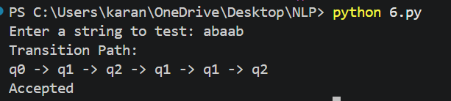

Section 3: Smart Pattern Matching Engine using Regular Expressions.

Problem Understanding
Develop a text search engine using Regular Expressions to search different patterns from text.
Supported searches
- Date
- Phone Number
- Hashtag
- Mention
- Prefix
- Suffix
Algorithm:
- Import re.
- Read paragraph.
- Display menu.
- Apply corresponding Regex.
- Print all matches.
Code:
import re
text = """Meeting on 12/09/2026
Call 9876543210
#NLP
@OpenAI
natural language processing"""
while True:
print("\n1.Search Date")
print("2.Search Phone Number")
print("3.Search Hashtag")
print("4.Search Mention")
print("5.Search Prefix")
print("6.Search Suffix")
print("7.Exit")
choice = int(input("Enter Choice: "))
if choice == 1:
print(re.findall(r'\b\d{2}/\d{2}/\d{4}\b', text))
elif choice == 2:
print(re.findall(r'\b[6-9]\d{9}\b', text))
elif choice == 3:
print(re.findall(r'#\w+', text))
elif choice == 4:
print(re.findall(r'@\w+', text))
elif choice == 5:
prefix = input("Enter Prefix: ")
print(re.findall(r'\b' + prefix + r'\w*', text))

elif choice == 6:
suffix = input("Enter Suffix: ")
print(re.findall(r'\b\w*' + suffix + r'\b', text))
elif choice == 7:
break
else:
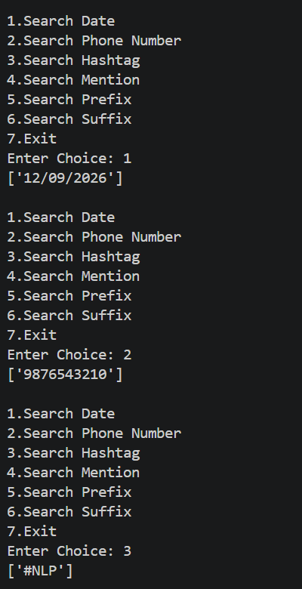
print("Invalid Choice")
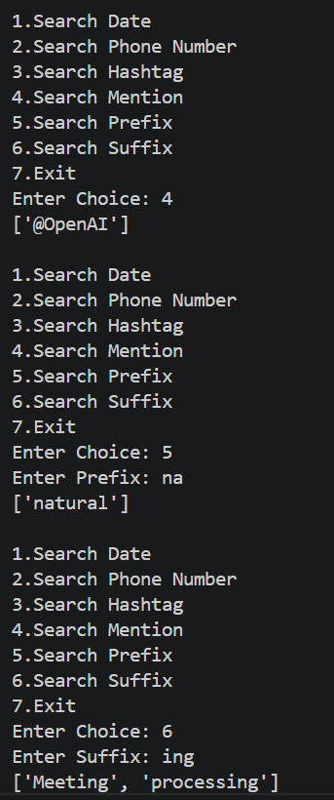
Output:
